**Requirements Model Report**

Image result for instant edge logo

**The Enterprise Transformation Platform**

|  |  |
| --- | --- |
|  |  |
|  |  |
|  |  |
|  |  |
|  |  |

|  |  |
| --- | --- |
| Document Reference: | ISS_IE_RMR_1.0 |
| Client: | **I**nstant **E**dge |
| Project: | **I**nstant **E**dge- Manage Operations Module |
| Document Title: | Requirements Model Report |
| Version | 1.0 |
| Date | 25/08/2016 |
| Author | Selvaraju Vignesh |
| Approver | Mathias Behne |

**Amendment History:**

|  |  |  |  |  |  |
| --- | --- | --- | --- | --- | --- |
| Version | Review & Approval Form Number | Date | Brief description of amendments and affected pages, paragraph | Author | Reviewer |
| 1.0 | ISS/IE/RMR/1.0 | 20/09/2016 | Initial version | Selvaraju Vignesh | Vrinda Gupta |

**Team Members:**

|  |  |  |
| --- | --- | --- |
| **Name** | **Group** | **Matriculation No.** |
| Rameswari Mohanty | SE24/4FT | A0148532E |
| Vrinda Gupta | SE24/4FT | A0148518X |
| Vignesh Selvaraju | SE24/4FT | A0148576N |
| Zhao Pengcheng | SE24/4FT | A0148528W |
| Keerti Kadevarmath | SE24/4FT | A0150485E |

Table of Contents

1. Brief Description 4

2. Domain Object Model 7

3. Participating Objects 7

1. Brief Description:

The document is to depict the overall model of the System derived from the requirements. The requirements were gathered primarily from the ITIL framework.

1. Domain Object Model

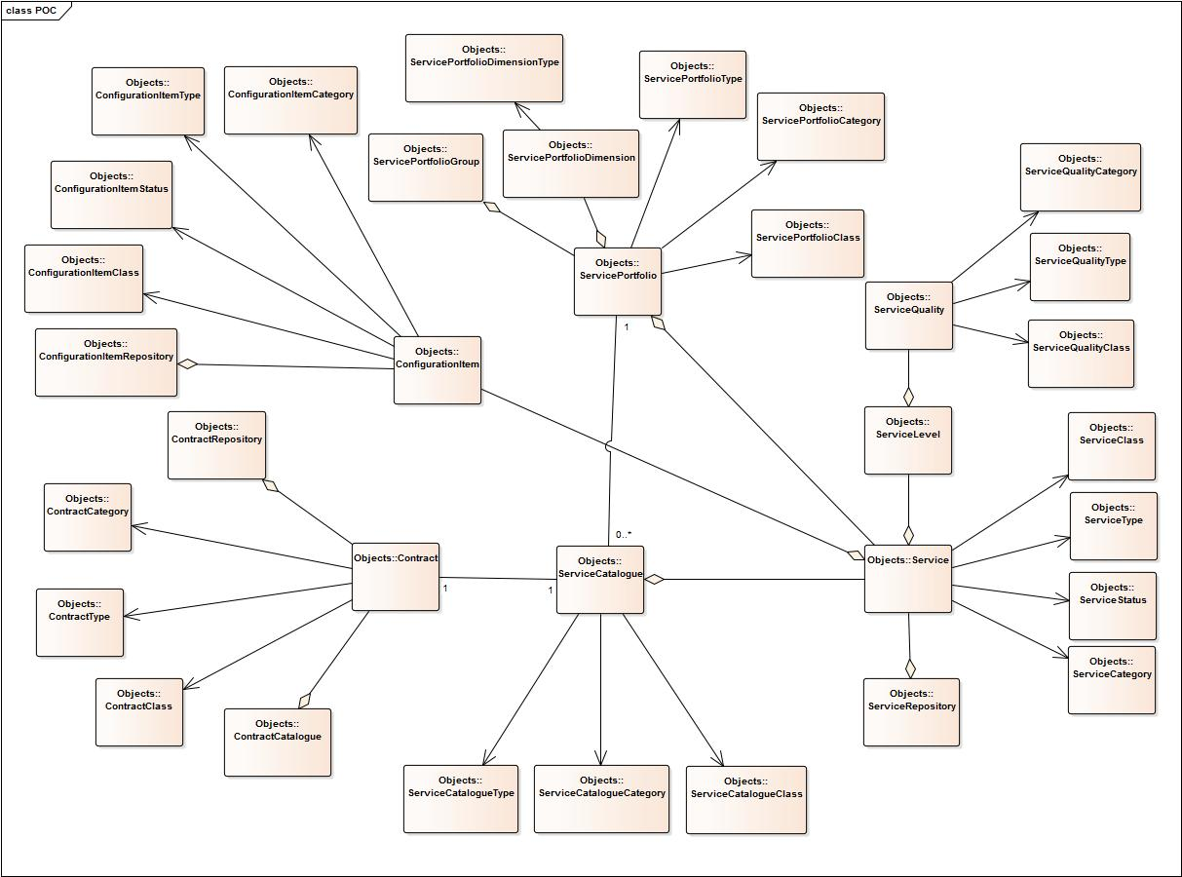

1. Participating Object
   1. Service

The Service object denotes the Services.

* 1. ServiceClass

The ServiceClass object denote the ServiceClass attribute of a Service.

* 1. ServiceType

The ServiceType object denote the ServiceType attribute of a Service.

* 1. ServiceStatus

The ServiceStatus object denote the ServiceStatus attribute of a Service.

* 1. ServicCategory

The ServiceCategory object denote the ServiceCategory attribute of a Service.

* 1. ServiceRepository

The ServiceRepository object contains collection of all Services.

* 1. ServiceLevel

The ServiceLevel object denote the ServiceLevel attribute of a Service.

* 1. ServiceQuality

The ServiceQuality object denote the ServiceQuality attribute of a Service.

* 1. ServiceQualityCategory

The ServiceQualityCategory object denote the Category of a ServiceQuality.

* 1. ServiceQualityType

The ServiceQualityType object denote the Type of a ServiceQuality.

* 1. ServiceQualityClass

The ServiceQualityClass object denote the Class of a ServiceQuality.

* 1. ServiceCatalogue

The ServiceCatalogue object contains a collection of Services.

* 1. ServiceCatalogueType

The ServiceCatalogueType denote the type of ServiceCatalogue.

* 1. ServiceCatalogueCategory

The ServiceCatalogueCategory denote the category of ServiceCatalogue.

* 1. ServiceCatalogueClass

The ServiceCatalogueClass denote the class of ServiceCatalogue.

* 1. ServicePortfolio

The ServicePortfolio contains a collection of Services.

* 1. ServicePortfolioGroup

The ServicePortfolioGroup denote the group of ServicePortfolio.

* 1. ServicePortfolioDimension

The ServicePortfolioDimension denote the dimensions for ServicePortfolios.

* 1. ServicePortfolioDimensionType

The ServicePortfolioDimensionType denote the types for ServicePortfolioDimensions.

* 1. ServicePortfolioType

The ServicePortfolioType denote the type for ServicePortfolios.

* 1. ServicePortfolioCategory

The ServicePortfolioCategory denote the category for ServicePortfolios.

* 1. ServicePortfolioClass

The ServicePortfolioClass denote the class of ServicePortfolio.

* 1. Contract

The Contract denote the binding contract between Users.

* 1. ContractRepository

The ContractRepository denote the collection of all Contracts.

* 1. ContractCategory

The ContractCategory denote the category of Contracts.

* 1. ContractType

The ContractType denote the type of Contracts.

* 1. ContractClass

The ContractClass denote the class of Contracts.

* 1. ContractCatalogue

The ContractCatalogue denote the catalogue of Contracts.

* 1. ConfigurationItem
  2. ConfigurationItemRepository
  3. ConfigurationItemClass
  4. ConfigurationItemStatus
  5. ConfigurationItemType
  6. ConfigurationItemCategory